CHAPTER 1
Introduction

  - SCOPE OF THE PROJECT
In a Peer-to Peer network, files are shared among various users without the need for a file hosting server; thereby the workload on the server is eliminated and is shared among the clients like in an adhoc-network environment. In this, files are divided into fragments and transferred out of order among nodes trying to download them. Individual nodes penalize and
reward other nodes, adjacent in the BitTorrent overlay, depending on how willing others are to share data[1]. The P2P file sharing has lately been facing various issues that has led to its shutdown in multiple countries and is threatened to be wiped off the internet in the near future. The proposed model is devised in such a way to overcome these issues.
Since the internet is recently being used for the transfer of large sized files, mostly in GB’s, the concept of hosting those files from expensive servers sounds tedious and infeasible. The P2P file sharing concept which eliminates the need for a server to host a file and distributes the file hosting task to each of the clients currently downloading or has finished downloading the file is used to overcome this issue. However, recently researchers have discovered that 75% of the P2P file sharing is focused on sharing illegal and copyrighted files in the internet. This made various law enforcements to treat P2P file sharing as a whole as an illegal concept, but to disprove these assumptions only few ideas have been proposed. One of which is ours, the Advanced Bittorrent System.

CHAPTER 2
System study

2.1 EXISTING SYSTEM
In the existing system, users are allowed to download in the P2P network anonymously, allowing them to download/upload any content they want. This has recently attracted government concern due to various copyright infringements in media and software industries. The Exisiting system builds its overlays by randomly selecting peers, a fact that has the potential to seriously handicap both individual performance and waste global network resources[1].It does not enforce any fair usage among the P2P users, resulting in a less efficient downloads/uploads, nor does there exist any monopoly organization to control and manipulate the P2P networks legally. This has resulted in isolated websites run by both pirates and legal organizations to cater for the needs of users all over the world.BitTorrent is an open system and there is no guarantee that all users will be co-operating in an open network[3]. There is no proper method to detect leechers who spoil the P2P network efficiency. Adding to these issues is the current law enforcements in various countries thriving to shut down the P2P networks completely, and few of those have even succeeded.
P2P file sharing is currently considered by all governments as a means to share files illegally among various countries and its users. This assumption if proved completely will deprive the users of their ability to share legal files in an organized way. If the existing system continues, in the near future P2P file sharing will be completely obliviated from the internet.

2.1.1 Disadvantages
- The current P2P sharing is not organized and is scrambled across the internet due to various issues such as low security, ISP’s blocking and rules of the law enforcements.
- Due to anonymity among P2P users, there is a huge efficiency breakdown in the network.
- It allows any type of files, may it be a virus or a copyrighted file to be uploaded by anonymous users from anywhere in the world.
- The files in the P2P network are not organized, so anyone can upload any file that could be an exact copy of a file that already exists in the network.
- Before uploading, the files are not analyzed so users are to believe the file only as it has been described by the user whose identity is anonymous and credibility unknown.

2.2 PROPOSED SYSTEM
In our proposed system, we try to solve the issues mentioned in the existing system by designing a standalone BitTorrent based P2P file sharing application and a P2P server to organize all clients and file sharing in the P2P network. The proposed system eliminates not all but at least most of the issues mentioned as a disadvantage in the existing system. Users are organized in the P2P network by requiring them to register and expose their identity while uploading and downloading files. Unlike the anonymity offered in the existing system, the proposed system allows users to be grouped in a social network and monitors their activities. Users can view other user’s interests and their activities and can be friend among themselves to make P2P file sharing efficient wherein, if a file is required by any user, he/she can request the file from other users who have that file. These features are not available in the Existing system because it promotes anonymity to share any kinds of files.
As anonymity is eliminated, issues like uploading copyright infringed files to the network and uploading viruses into the P2P network will be reduced. In addition, the proposed system has an analysis phase before uploading, to analyze the files for known copyright infringements, virus/malware threats and duplication that prevent users from uploading such content into the P2P network.

2.2.1 Features of Proposed System
- The Advanced Bittorrent system allows users to be organized by imposing registration before installation and eliminates anonymity.
- The users in the network can communicate among themselves, exposing their identity to other users and form a social group to share files of their interests.
- Users can also share their favorite contents so others could view and download it only if they require.
- Files that are fake, infected, copyrighted or duplicate will be prevented from being uploaded into the P2P network.
- Download and upload are more secure since users download only from their friends mostly.
- Due to these features, the number of P2P users around the world will increase dramatically thereby increasing the efficiency of P2P sharing.

CHAPTER 3
REQUIREMENT SPECIFICATIONS

3.1 SOFTWARE REQUIREMENTS

- Platform : Windows Xp
- Front End : Visual C++, MFC
- Back End : MS Access with ODBC

3.2 HARDWARE REQUIREMENTS

- Processor : Pentium II 266 MHz
- RAM : 64 MB
- HDD : 10MB of free space

CHAPTER 4
LANGUAGE SPECIFICATION

4.1 C++
C++ is a statically typed, free-form, multi-paradigm, compiled, general-purpose programming language. It is regarded as an intermediate-level language, as it comprises both high-level and low-level language features. Developed by Bjarne Stroustrup starting in 1979 at Bell Labs, C++ was originally named C with Classes, adding object oriented features, such as classes, and other enhancements to the C programming language. The language was renamed C++ in 1983, as a pun involving the increment operator.
C++ is one of the most popular programming languages and is implemented on a wide variety of hardware and operating system platforms. As an efficient compiler to native code, its application domains include systems software, application software, device drivers, embedded software, high-performance server and client applications, and entertainment software such as video games.Several groups provide both free and proprietary C++ compiler software, including the GNU Project, Microsoft, Intel and Embarcadero Technologies. C++ has greatly influenced many other popular programming languages, most notably C# and Java. Other successful languages such as Objective-C use a very different syntax and approach to adding classes to C.

4.2 THE BITTORRENT PROTOCOL
BitTorrent is a protocol that supports the practice of peer-to-peer file sharing and is used for distributing large amounts of data over the Internet. BitTorrent is one of the most common protocols for transferring large files and peer-to-peer networks have been estimated to collectively account for approximately 43% to 70% of all Internet traffic (depending on geographical location) as of February 2009. In November of 2004 BitTorrent was responsible for 35% of all Internet traffic. As of February 2013, BitTorrent was responsible for 3.35% of all worldwide bandwidth, more than half of the 6% of total bandwidth dedicated to file sharing.
Programmer Bram Cohen designed the protocol in April 2001 and released the first available version on July 2, 2001. BitTorrent clients are available for a variety of computing platforms and operating systems including an official client released by Bittorrent, Inc.

4.3 MFC
MFC (Microsoft Foundation Classes) was introduced in 1992 with Microsoft's C/C++ 7.0 compiler for use with 16-bit versions of Windows as an extremely thin object-oriented C++ wrapper for the Windows API. C++ was just beginning to replace C for development of commercial application software at the time. In an MFC program, direct Windows API calls are rarely needed. Instead, programs create objects from Microsoft Foundation Class classes and call member functions belonging to those objects. Many of those functions share their names with corresponding API functions.
4.3.1 Features of MFC
At the time of its introduction, MFC provided C++ macros for Windows message-handling (via Message Maps), exceptions, run-time type identification (RTTI), serialization and dynamic class instantiation. The macros for message-handling aimed to reduce memory consumption by avoiding gratuitous virtual table use and also to provide a more concrete structure for various Visual C++-supplied tools to edit and manipulate code without parsing the full language. The message-handling macros replaced the virtual function mechanism provided by C++.
The macros for serialization, exceptions, and RTTI predated availability of these features in Microsoft C++ by a number of years. 32-bit versions of MFC, for Windows NT 3.1 and later Windows operating systems, used compilers that implemented the language features and updated the macros to simply wrap the language features instead of providing customized implementations, realizing upward compatibility.
4.3.2 MFC Message Handling
Event handling in MFC is handled by processing event messages from the main application’s event queue. From the event queue, the corresponding object associated with that event is invoked and the object invokes the corresponding function to processs the event. As a parameter the object of the class that invoked the event and its X,Y position are sent to the function that handles the message.

4.4 ODBC
ODBC (Open Database Connectivity) is a standard C programming language middleware API for accessing database management systems (DBMS). The designers of ODBC aimed to make it independent of database systems and operating systems; an application written using ODBC can be ported to other platforms, both on the client and server side, with few changes to the data access code.
ODBC accomplishes DBMS independence by using an ODBC driver as a translation layer between the application and the DBMS. The application uses ODBC functions through an ODBC driver manager with which it is linked, and the driver passes the query to the DBMS. An ODBC driver can be thought of as analogous to a printer or other driver, providing a standard set of functions for the application to use, and implementing DBMS-specific functionality. An application that can use ODBC is referred to as "ODBC-compliant". Any ODBC-compliant application can access any DBMS for which a driver is installed. Drivers exist for all major DBMSs, many other data sources like address book systems and Microsoft Excel, and even for text or CSV files.
4.5 STUDY OF WIRED PROTOCOLS
4.5.1 Connection-oriented protocol
A connection-oriented networking protocol is one which identifies traffic flows by some connection identifier rather than by explicitly listing source and destination addresses.
4.5.2 Connectionless Protocol
Connectionless protocol describes communication between two network end points in which a message can be sent from one end point to another without prior arrangement
4.5.3 Transmission Control Protocol
The Transmission Control Protocol (TCP) is one of the core protocols of the Internet protocol suite. TCP provides reliable, in-order delivery of a stream of bytes, making it suitable for applications like file transfer and e-mail. It is so important in the Internet protocol suite that sometimes the entire suite is referred to as "the TCP/IP protocol suite."
4.5.4 Applicability of TCP
TCP is a reliable stream delivery service that guarantees to deliver a stream of data sent from one host to another without duplication or losing data. Since packet transfer is not reliable, a technique known as positive acknowledgement with retransmission is used to guarantee reliability of packet transfers. This fundamental technique requires the receiver to respond with an acknowledgment message as it receives the data. The sender keeps a record of each packet it sends, and waits for acknowledgment before sending the next packet. The sender also keeps a timer from when the packet was sent, and retransmits a packet if the timer expires. The timer is needed in case a packet becomes lost or corrupt.

4.5.5 Key Features
The key features of TCP are:
• Retransmission of lost packets
• Discarding duplicate packets
• Error-free data transfer
• Flow control
• Congestion control

4.5.6 Error Free Data Transmission
Sequence numbers and acknowledgments cover discarding duplicate packets, retransmission of lost packets, and ordered-data transfer. To assure correctness a checksum field is included.TCP uses an end-to-end flow control protocol to avoid having the sender send data too fast for the TCP receiver to reliably receive and process it. TCP uses a sliding window flow control protocol. In each TCP segment, the receiver specifies in the receive window field the amount of additional received data (in bytes) that it is willing to buffer for the connection. The sending host can send only up to that amount of data before it must wait for an acknowledgment and window update from the receiving host.
4.5.7 Congestion Control
The final main aspect of TCP is congestion control. TCP uses a number of mechanisms to achieve high performance and avoid 'congestion collapse', where network performance can fall by several orders of magnitude. These mechanisms control the rate of data entering the network, keeping the data flow below a rate that would trigger collapse.
4.5.8 User Datagram Protocol
User Datagram Protocol (UDP) is one of the core protocols of the Internet protocol suite. Using UDP, programs on networked computers can send short messages sometimes known as datagrams (using Datagram Sockets) to one another. UDP is sometimes called the Universal Datagram Protocol.
UDP does not guarantee reliability or ordering in the way that TCP does. Datagrams may arrive out of order, appear duplicated, or go missing without notice. Avoiding the overhead of checking whether every packet actually arrived makes UDP faster and more efficient, at least for applications that do not need guaranteed delivery. Time-sensitive applications often use UDP because dropped packets are preferable to delayed packets. UDP's stateless nature is also useful for servers that answer small queries from huge numbers of clients. Unlike TCP, UDP is compatible with packet broadcast (sending to all on local network) and multicasting (send to all subscribers).

4.5.9 UDP Advantages

It is a simple connectionless protocol.

It does not include the overhead needed to detect reliability and maintain connection- oriented semantics.

UDP packets require considerably less processing at the transmitting and receiving hosts.

It does not maintain the illusion of a data stream.

The packets can be transmitted as soon as they are sent by the application instead of waiting in line behind other data in the stream; similarly, data can be delivered to the application as soon as it arrives at the receiving host instead of waiting in line behind missing data.

It is less heavy to manage for the OS.

Operating system does not need to keep UDP connection information for every peer host, UDP/IP is more appropriate for large-scale distributed systems where each host communicates with many destinations simultaneously.
CHAPTER 5
SYSTEM DESIGN

5.1 ARCHITECTURE
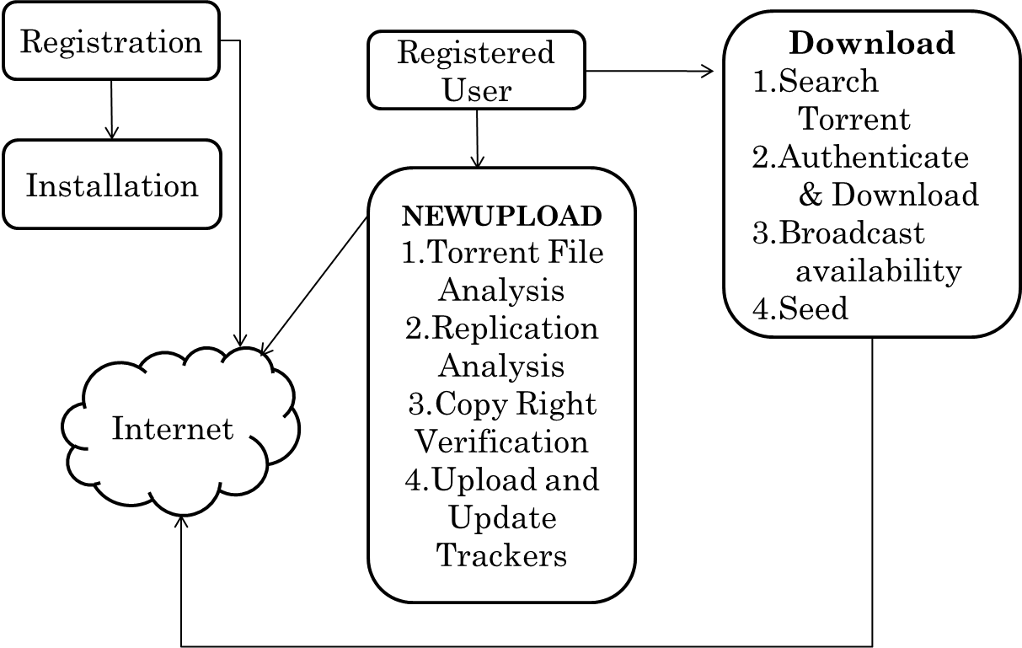

Fig. 5.1 : Architecture Diagram

5.2 UML DIAGRAMS

5.2.1 Use Case Diagram
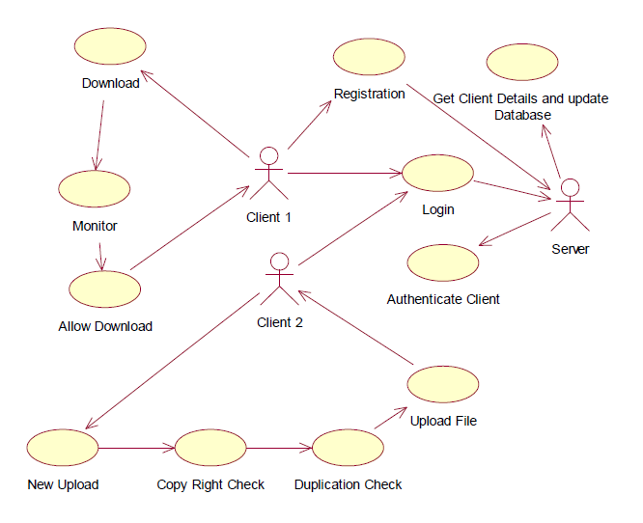
Fig. 5.2 : Use Case Diagram for ABTA

5.2.2 Sequence Diagram

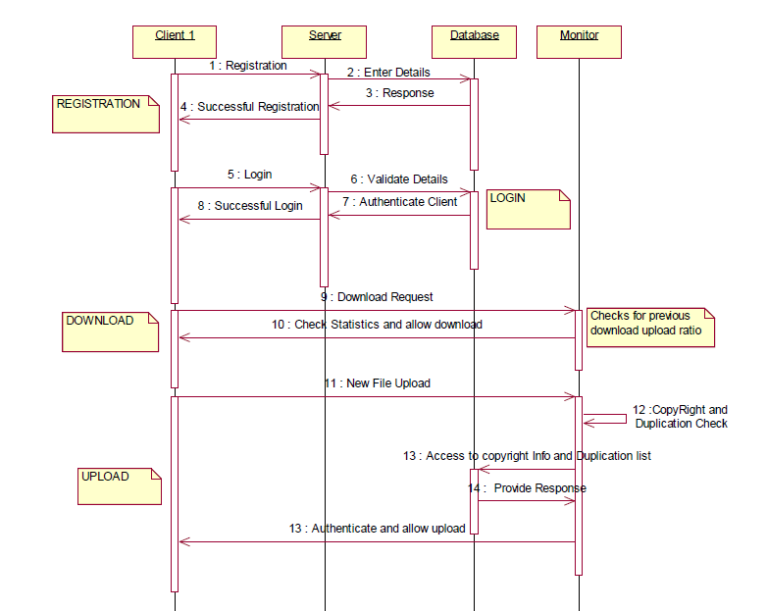

Fig. 5.3 : Sequence Diagram for ABTA

5.2.3 Collaboration Diagram
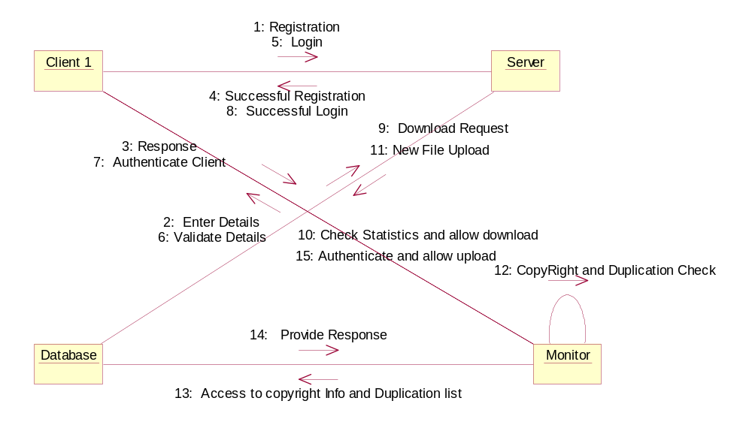

Fig. 5.4 : Collaboration Diagram for ABTA

5.2.4 Activity Diagram
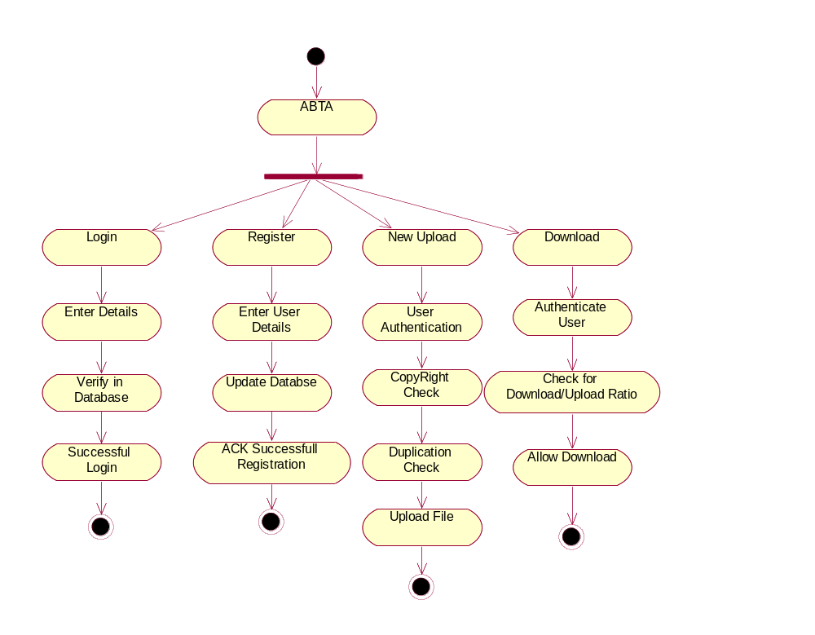Fig. 5.5 : Activity Diagram for ABTA

CHAPTER 6
MODULE DESCRIPTION

The proposed system consists of four modules namely,
- Registration
- Login and verification
- Download
- Upload

6.1 REGISTRATION
To implement this system every client must be linked to a server that runs MS ODBC as backend to authenticate and register users. The server runs infinitely to accept requests from multiple clients at the same time. During registration, details such as user interests and his location are gathered to later allow the user to form a social group and find users of his own interest. This module requires that the user has no previous installation of the client in his system and if he has, a thorough uninstall is required to continue with the registration. The Registration module is similar to an Installation wizard but gathers registration information to organize users in the P2P network.

6.2 LOGIN AND VERIFICATION
Once the registration begins, the information gathered from the user are verified with the server dynamically and after successful registration the server updates the user database. Once the user registers, he cannot register again from the same system or with the same user name. From the second time whenever the applications starts, the user has to login to the application via the server. The login session is used to manage the user activity and statistics monitoring.

6.3 DOWNLOAD
This module handles the downloading of files. The download/upload statistics are regularly monitored and each time the user initiates a download, his upload/download ratio is verified and only if his seed ratio is below 2.0 he will be allowed to download. The download module does not need to enforce any analysis since it will be analyzed while uploading, so the user can start downloading the file securely.
When a file download is initiated after authentication, the active peers sharing the file are displayed to the user when he highlights the download entry of that file. From the peers list the user can add an external peer to download from or remove an existing peer from the list. The peer-to-peer communication which was unavailable in the existing system is overcome by allowing the peers to communicate with each other. Users can view other user’s profiles which reveal their interests in downloading, their location and other parameters that help users to socialize in the internet. Based on these details users can form a social group where they are privileged with other features such as sharing their folders with other friends, viewing friend’s activities etc. These features help boost the number of peers involved in a particular file and thereby decreases the download time and upload time of all users. After successful download of a file, it is automatically added to the seed queue where the client satisfies other user’s file requests by uploading.
Users behind proxy servers can also download and upload by making use of the Proxy settings, which forwards ports to and from the client and the proxy server. However Configuring proxy settings require server password, if there exists any to enable port forwarding.

6.4 UPLOAD
This module analyses the files for viruses, copyright infringement and Duplication before creating the .torrent file for uploading. While uploading the user is required to categorize the file under its type, and genre which will help torrent search easier. Files are analyzed based on the search term, file name, file size in bytes, its categorization, unique file serial number generated by concatenating multiple file parameters etc. These details are verified with the server and if the server allows the file to be added to the database, the user is allowed to upload the file. This module also scans files for known virus infections by making use of the built in antivirus software. If the file scanned is infected, the user will not be allowed to continue the upload. Users can gain privilege based on how much he has contributed to the P2P network by uploading. This privilege will decide the bandwidth allocated to the user for download/upload, maximum number of peers the user can be connected to at the same time and maximum number of concurrent connections etc. Users can also send text messages among themselves while still downloading or uploading, this creates a social among Torrent downloaders and will induce users to upload their part to the P2P network. This considerably reduces the number of leeches in the network and encourages all users to seed till their required ratio is met.

CHAPTER 7
SYSTEM TESTING AND MAINTENANCE

7.1 TESTING
Testing is a set of activities that can be planned in advance and conducted systematically. For this reason a template for software testing, a set of steps into which we can place specific test case design techniques and testing methods should be defined for software process.
Testing often accounts for more effort than any other software engineering activity. If it is conducted haphazardly, time is wasted, unnecessary effort is expanded, and even worse, errors sneak through undetected. It would therefore seem reasonable to establish a systematic strategy for testing software
There are two type of testing according their behaviors
  - Unconventional Testing
  - Conventional Testing
7.1.1 Unconventional Testing
Unconventional testing is a process of verification which is doing by SQA (Software Quality Assurance) team. It is a prevention technique which is performing from beginning to ending of the project development. In this process SQA team verifying the project development activities and insuring that the developing project is fulfilling the requirement of the client or not.
In this testing the SQA team follows these methods:
1. Peer review
2. Code walk and throw
3. Inspection
4. Document Verification

7.1.2 Conventional Testing
Conventional Testing is a process of finding the bugs and validating the project. Testing team involves in this testing process and validating that developed project is according to client requirement or not. This process is a correction technique where testing team find bugs and reporting to the development team for correction on developed project built.

7.2 Testing Methodologies
7.2.1 Unit Testing
The procedure level testing is made first. By giving improper inputs, the errors occurred are noted and eliminated. Then the web form level testing is made.
7.2.2 Integration Testing
Testing is done for each module. After testing all the modules, the modules are integrated and testing of the final system is done with the test data, specially designed to show that the system will operate successfully in all its aspects conditions. Thus the system testing is a confirmation that all is correct and an opportunity to show the user that the system works.
7.2.3 Module Testing
Module Testing is a process of testing the system, module by module. It includes the various inputs given, outputs produced and their correctness. By testing in this method we would be very clear of all the bugs that have occurred.
7.2.4 Interface Testing
The Interface Testing is performed to verify the interfaces between sub modules while performing integration of sub modules aiding master module recursively.

7.2.5 Validation Testing
The final step involves Validation testing, which determines whether the software function as the user expected. The end-user rather than the system developer conduct this test most software developers as a process called “Alpha and Beta Testing” to uncover that only the end user seems able to find.
The compilation of the entire project is based on the full satisfaction of the end users. In the project, validation testing is made in various forms.

7.3 TESTING STRATEGIES
A number of software testing strategies have been proposed in the literature. All provide the software developer with a template for testing and all have the following generic characteristics:
- Testing begins at the component level and works “outward” toward the integration of the entire computer-based system.
- Different testing techniques are appropriate at different points in time.
- The developer of the software conducts testing and for large projects, independent test group.

7.4 MAINTENANCE
The objectives of this maintenance work are to make sure that the system gets into work all time without any bug. Provision must be for environmental changes which may affect the computer or software system. This is called the maintenance of the system.
Maintenance plays a vital role. The system liable to accept any modification after its implementation. This system has been designed to favour all new changes. Doing this will not affect the system’s performance or its accuracy.
CHAPTER 8
CONCLUSION AND FUTURE ENHANCEMENTS

Compared to the existing Peer-to-Peer file sharing applications which lacks the management ability of a server hosting a file and suffers from various issues, our proposed model is believed to be way advantageous, wherein the current P2P issues are solved and the server load is minimized. The Advanced BitTorrent system is a standalone application and does not depend on any other infrastructure other than the low level TCP/UDP communication to download and communicate with users.

Future enhancements include developing standalone global tracker servers to bring all peers into one circle to enhance the P2P efficiency, TCP based file transfer among users and a better concurrency control for server requests. The peers will be organized based on their geological location and hop distance. This will further improve the P2P efficiency and decrease the need for server hosted HTTP file transfers.

APPENDIX

Appendix 1 – CODE SNIPPETS

DOWNLOAD

BOOL CABTDlg::StartDownload()
{
ASSERT( NULL == m_hDownloader );
CString strPath;
::GetModuleFileName( AfxGetInstanceHandle(),
strPath.GetBuffer( _MAX_PATH ), _MAX_PATH );
strPath.ReleaseBuffer();
int nPos = strPath.ReverseFind( _T('\\') );
ASSERT( -1 != nPos );
CString strStartupPath = strPath.Left( nPos + 1 );

HTorrentFile hTorrentFile = FTK_Torrent_Open( m_strTorrentFile, CP_ACP, NULL);
if ( NULL == hTorrentFile )
{
AfxMessageBox( _T("torrent file null") );
return FALSE;
}
CByteArray arryPreAllocFile;
arryPreAllocFile.SetSize( FTK_Torrent_GetFilesCount( hTorrentFile ) );
memset( arryPreAllocFile.GetData(), 0x00, arryPreAllocFile.GetSize() );
nPos = m_strTorrentFile.ReverseFind( _T('\\') );
ASSERT( -1 != nPos );
CString strDestPath = m_strTorrentFile.Left( nPos + 1 );
m_strKeyValue = FTK_Torrent_GetHexInfoHash( hTorrentFile );
m_strKeyValue.Replace( _T("%"), _T("") );
m_hDownloader = FTK_Downloader_Open();
AfxMessageBox(m_strDestPath);
BOOL bRet = FTK_Downloader_Init(
m_hDownloader,
m_strTorrentFile,
arryPreAllocFile.GetData(),
arryPreAllocFile.GetSize(),
FALSE,
m_strDestPath + _T("\\") + FTK_Torrent_GetTorrentName( hTorrentFile ),
strStartupPath + _T( "Config.INI" ),
strStartupPath + _T( "Log\\" ) + _T( "Downloader.log" ),
strStartupPath + m_strKeyValue + _T( ".status" ),
NULL, CP_ACP );

if ( FALSE == bRet )
{
FTK_Downloader_Close( m_hDownloader );
m_hDownloader = NULL;
AfxMessageBox( _T("error line 303") );
return FALSE;
}

bRet = FTK_Downloader_Execute( m_hDownloader );
if ( FALSE == bRet )
{
FTK_Downloader_Close( m_hDownloader );
m_hDownloader = NULL;
AfxMessageBox( _T("error line 312") );
return FALSE;
}

FTK_GlobalVar_AddTorrentSHA1( m_strKeyValue, m_hDownloader );
m_qwTotalFileSize = FTK_Torrent_GetFileSize( hTorrentFile );
m_dwPieceCount = FTK_Torrent_GetPieceCount( hTorrentFile );
if(!ABTUI::add_download_queue(hTorrentFile, m_hDownloader))
AfxMessageBox("error adding torrent to queue. startdownload line ");
tname=FTK_Torrent_GetTorrentName(hTorrentFile);
wstr=" Downloading " +tname;
update_activity(wstr);
return TRUE;
}

void CABTDlg::OnBnClickedButton1()//dialog box for proxy settings
{
ProxyDummy obj;
obj.OnProxySettings();
if(IDOK != obj.DoModal())
return;
int nProxyType =obj.m_nProxyType;
BOOL bAuthRequired = obj.m_bAuthRequired;
CString strProxyServer = obj.m_strProxyServer;
int nProxyPort = obj.m_nProxyPort;
BOOL bUseOnlyHTTP = obj.m_bUseOnlyHTTP;
CString strUserName = obj.m_strUserName;
CString strPassword = obj.m_strPassword;
AfxMessageBox( _T("line 54") );
if ( ( nProxyType > 0 && nProxyType <= 4 ) &&
!strProxyServer.IsEmpty() &&
( nProxyPort > 0 && nProxyPort <= 65535 ) )
{
if ( bAuthRequired && !strUserName.IsEmpty() &&!strPassword.IsEmpty() )
{
FTK_Proxy_SetAuthProxy( nProxyType,
strProxyServer, nProxyPort,
strUserName, strPassword );
}
else
{
FTK_Proxy_SetProxy( nProxyType,
strProxyServer, nProxyPort );
}
FTK_Proxy_SetOnlyTracker( bUseOnlyHTTP );
}
else
{
FTK_Proxy_SetType( PROXYTYPE_NOPROXY );
AfxMessageBox( _T("line 80") );
} }

REGISTRATION AND INSTALLATION – SERVER SIDE

int CABTServerDlg::register_user(CString info,CString ip)
{
CString name,pwd,email,interests,country,state;
pch=strtok_s(info.GetBuffer(),":",&context);
if(pch!=NULL)
name=pch;
pch=strtok_s(NULL,":",&context);
if(pch!=NULL)
pwd=pch;
pch=strtok_s(NULL,":",&context);
if(pch!=NULL)
email=pch;
pch=strtok_s(NULL,":",&context);
if(pch!=NULL)
interests=pch;
pch=strtok_s(NULL,":",&context);
if(pch!=NULL)
country=pch;
pch=strtok_s(NULL,":",&context);
if(pch!=NULL)
state=pch;
if(!add_user(name,pwd,email,interests,country,state))
return 0;
return 1;
}

void ABTUI::update_context()
{
peer_listCtrl.DeleteAllItems();
int context_id=ABTUI::cur_sel;
temp2=ABTUI::head;
while( temp2!=NULL )
{
if(temp2->id==context_id)
{
//AfxMessageBox("matched click");
peer_max=25;
peer_ret=0;
FTK_Stat_GetMiniPeerData(temp2->cur_tor, peer_list ,peer_ret , peer_max);
for(int i=0;i<peer_ret;i++){
A = peer_list[i].m_dwIP & 0x000000FF;
B = peer_list[i].m_dwIP & 0x0000FF00;
C = peer_list[i].m_dwIP & 0x00FF0000;
B = B >> 8;
C = C >> 16;
D = D >> 24;
strValue1.Format("%d.%d.%d.%d", A, B, C, D);
peer_listCtrl.InsertItem(0,strValue1);
strValue2.Format("%lu" ,peer_list[i].m_nPort);
peer_listCtrl.SetItemText(0,1,strValue2);}
}
temp2 = temp2->next;}

Appendix 2- SCREEN SHOTS

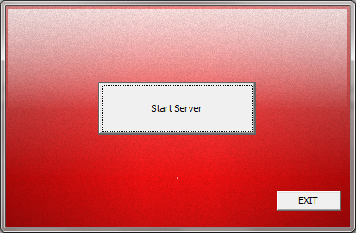

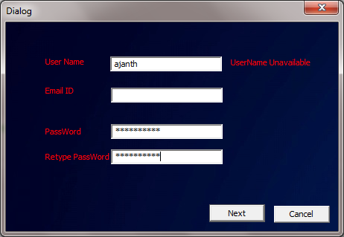

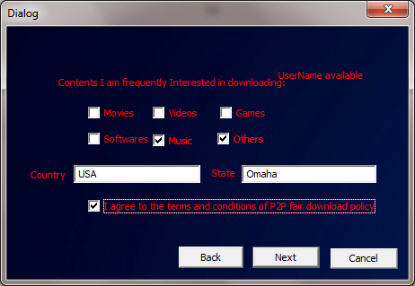

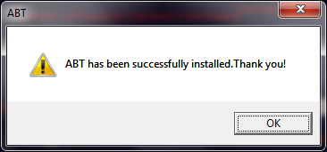

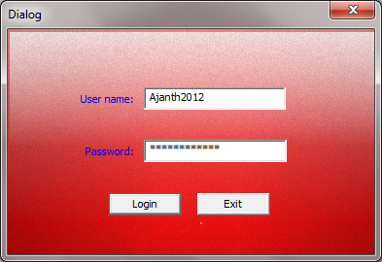
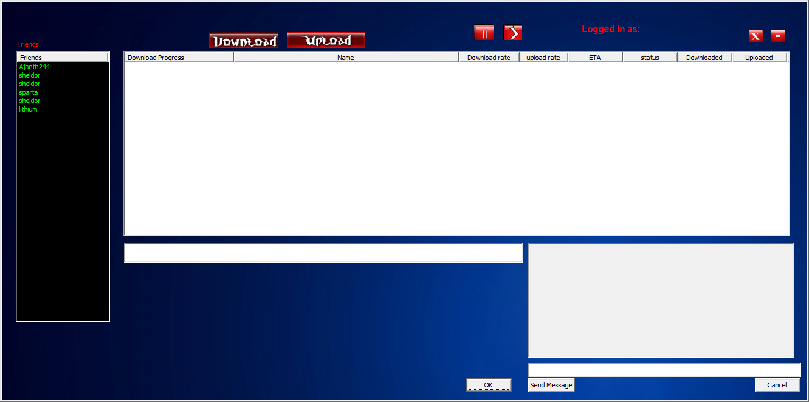

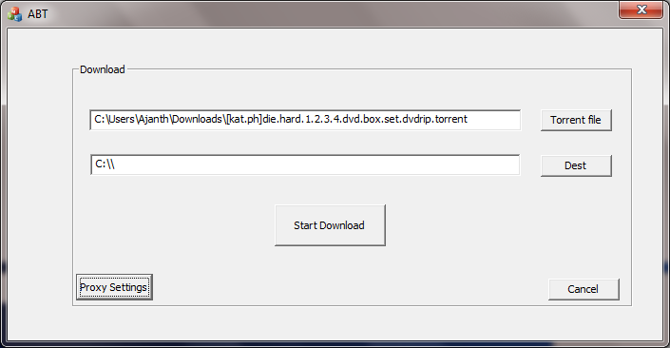

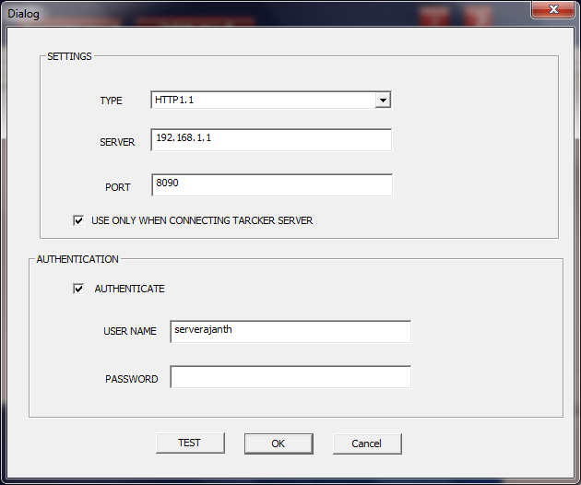

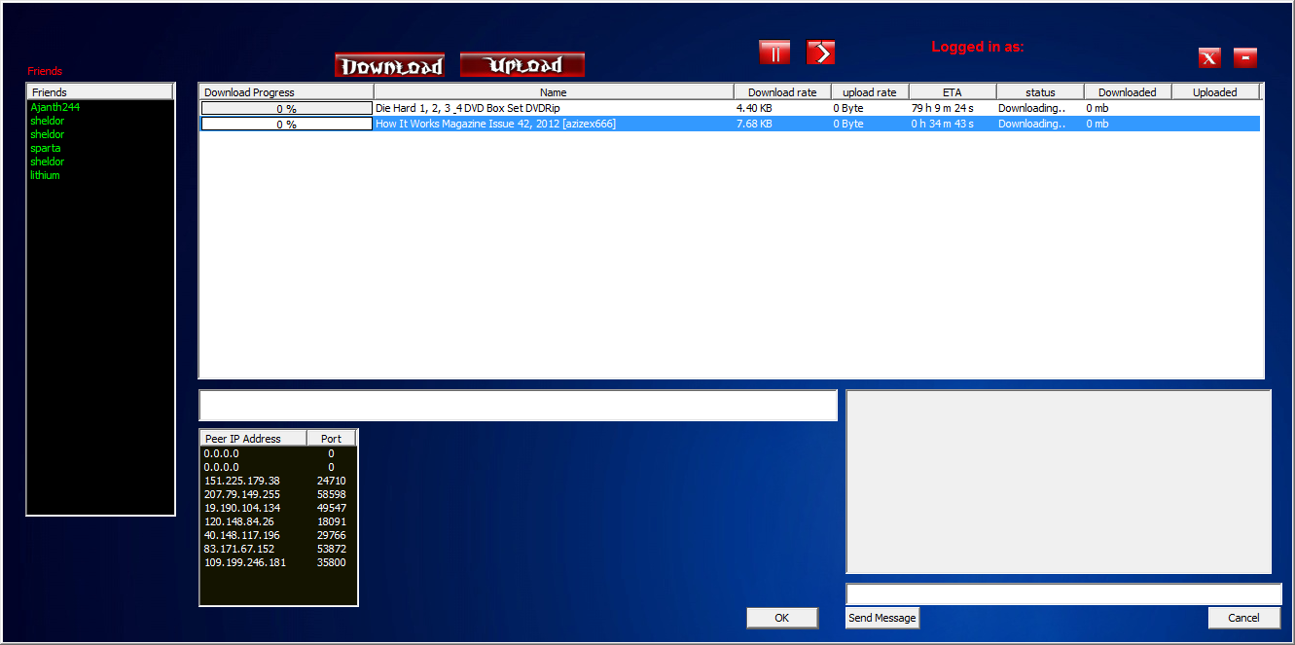

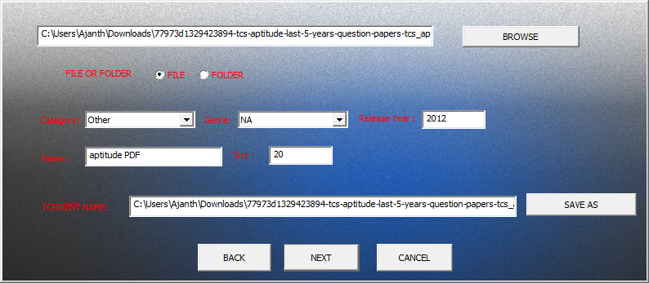

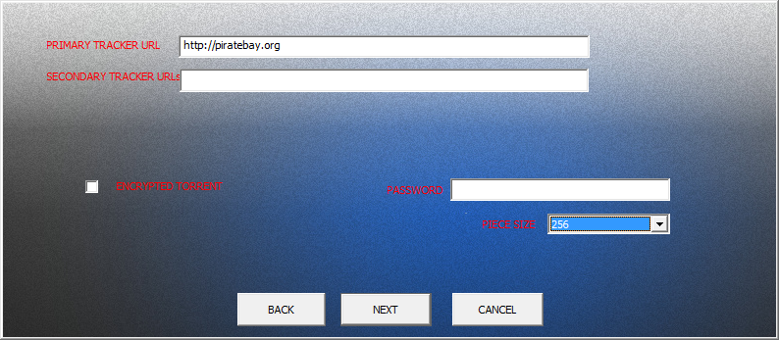

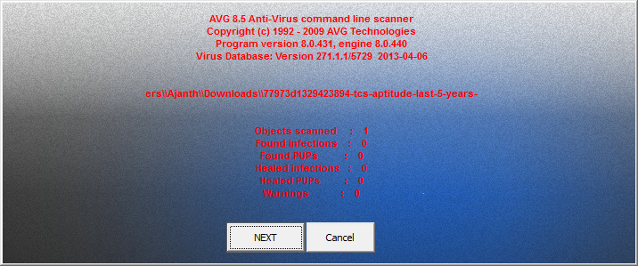



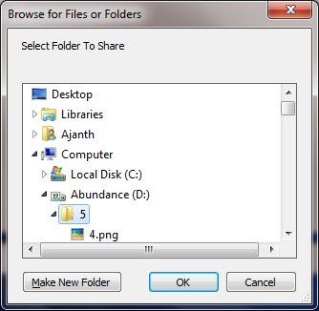

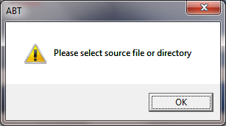

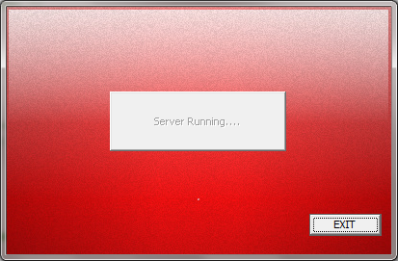

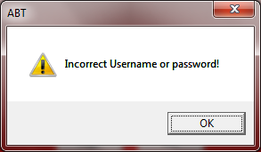

REFERENCES

- AsfandyarQureshi, "Exploring Proximity Based Peer Selection in a BitTorrent-like Protocol," in MIT 6.824 student project, ed, 2004.
- "Bencode," http://en.wikipedia.org/wiki/Bencode.
- Shu-Ming Chang and Ren-Song Ko (feb 2012), “Fast Enlarging a BitTorrent swarm via Social Networking” , Proc. International Conference son Information Networking, PP:239-244
- “RSA Encryption Algorithm” http://www.codeproject.com/Articles/4084/RSA-encryption-decryption.

